Capstone Project Report Guidelines
Introduction
This document can be used as a guide for writing the project report by students associated with MCA program.

Binding Instructions
Green colored hard bound report with CD/DVD attached in cover on the last page of bounded report.

Organization of report
- Outer title page (Green color)
- Inner title page
- Certificate in the format enclosed from the college
- Certificate of the organization where the project is carried out. (if any)
- Acknowledgment
- Abstract (not exceeding 250-300 words, indicating salient features of the work.)
- Table of Contents
- List of tables
- List of figures
- Nomenclature
- Text of report Chapters (Main material)
- References
- Appendices

Number of hard copies to be submitted
- One copy to the department.
- One copy to the concerned guide(s).
- One copy to be sent to external guide
- One copy to the candidate.

Before taking the final printout, the approval of the concerned guide(s) is mandatory and suggested corrections, if any, must be incorporated.
Proper attention is to be paid not only to the technical contents but also to the organization of the report and clarity of the expression. Due care should be taken to avoid spelling and typing errors.
The reports submitted to the department/guide(s) must be hard bound. The corrections, if any,
suggested by the guide/HOD have to be incorporated in the report before final submission.
Soft copy of Project Work
A soft copy on CD/DVD should be submitted after incorporating all the corrections. File structure of
soft copy as follows,

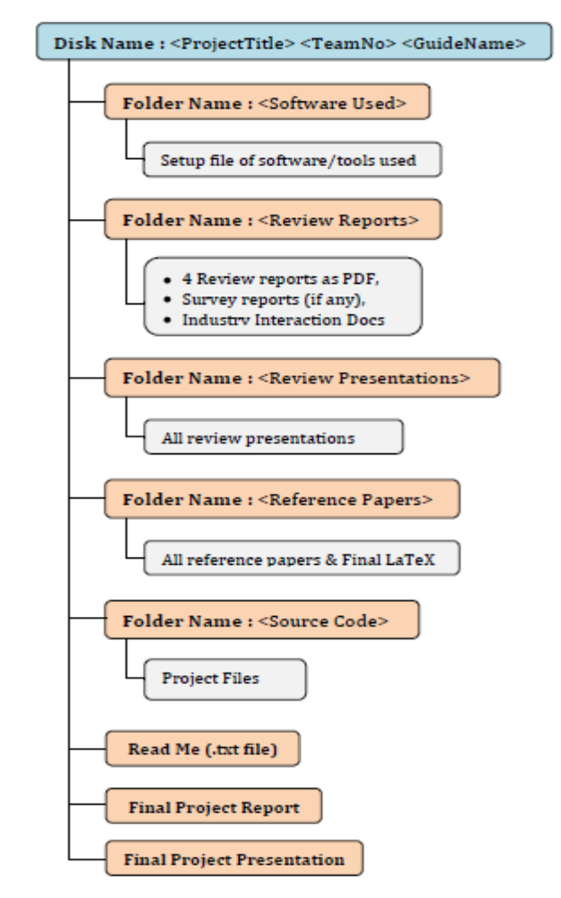

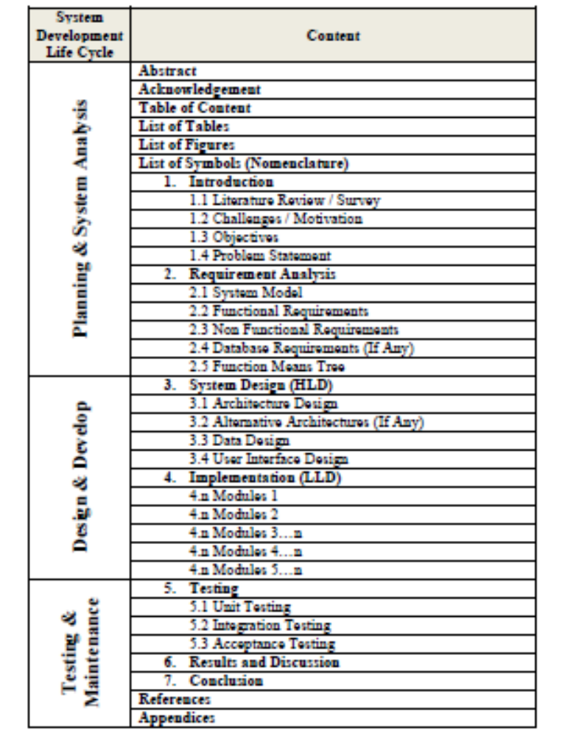
Abstract: An abstract brief summary which should start with an Introduction, existing system, challenges identified, methodology to solve the identified problem, results, conclusion and future work, approximately consisting of 250 ~ 300 words.

Acknowledgement: The authors of the report may include warm acknowledgments in recognition of the support and help rendered by different persons and organizations in the conduct of the project.

Table of Contents: For the ease of readily reaching the different sections of the report, a complete table of contents should be included indicating the sections and the corresponding page numbers.

List of Tables and Figures: For quick access to the tables referred to in the text, a list of tables and figures is essential. These lists are made on separate pages and should follow the Table of Contents page.

List of Symbols (Nomenclature):
The various symbols used in the body of the text are defined in detail on the first instance of their occurrence. However, a separate list of the brief definitions of all symbols should be included for easy comprehension of the report; should the symbol appear at a location far away from where it has been defined first, this list will be a great help. Some symbols appearing in this manual and their brief definitions are presented in the List of Symbols on page viii. As shown, the English alphabet based symbols appear first and then the Greek alphabet based symbols.

1. Introduction:
Literature Review/ Real Time Survey: The literature survey should consist of a discussion of the
papers read, including the problems addressed, the techniques used, and their advantages and disadvantages, which results into identifying challenges that motivate to solve the specified problem. This includes the current knowledge including substantive findings, as well as theoretical and methodological contributions to a particular topic.

Challenges / Motivation: Actual challenges of existing system are described here which in turn motivate towards implementing the proposed system and specifying the objectives of the project.

Problem Statement: A problem statement is a clear concise description of the issue(s) that need(s) to be addressed. It is used to center and focus at the beginning, keep the work on track during the effort, and is used to validate that the effort delivered an outcome that solves the problem statement.

Scope of Project: The scope of the project includes the service provided by the project and goals that need to be met to achieve a satisfactory result.

2. Requirement Analysis: Describe in 1 – 2 paragraph introductions to SRS.
2.1 System Model: Abstract level.
2.2 Functional Requirements:
2.3 Non-Functional Requirements
2.4 Database Requirements

3. System Design
3.1 Architecture Design
3.2 Alternative Architectures (If any)
3.3 Data Design
3.4 User Interface Design

4. Implementation
4.1 Module 1 : <Name of the module>
4.1.1 Module Description
4.1.2 Algorithm
4.1.3 Input and Expected Output
.
.
.
.
4.n Module n : <Name of the module>
4.n.1 Module Description
4.n.2 Algorithm
4.n.3 Input and Expected Output

5. Testing
5.1 Unit testing : Using test case documents & description
5.2 Integration testing : Using test case documents & description

6. Results and Discussion
Discussion of results under the specific condition/criteria in terms of screen shots/graphs and
explaining details for all expected output.

7. Conclusion & Future Work
Conclude the report on the bases of specified objectives, implementation method/techniques and
results and discussions performed on the project work. Also define the extension of the work which
can be carried further.

References : IEEE Standard must be followed. Following and the examples.

Book
[1] P.M. Morse and H. Feshback, Methods of Theoretical Physics. New York: McGraw Hill, 1953.

Journal Article
[2] S.K. Kenue and J.F. Greenleaf, “Limited angle multifrequency diffiaction tomography,” IEEE Trans. Sonics Ultrason., vol. SU-29, no. 6, pp. 213-2 17, July1982.

New edition of a book
[3] C. Brusaw, C. Aired, and W. Oliu, Handbook of Technical Writing, 3rd ed. New York: St. Martin’s Press, 1987.

Personal Interview/Communication
[4] Interview [or Personal Communication] with Prof. Elmer Hixon, BCE Department, The University of Texas at Austin, March 12, 1995.

Dissertation or thesis
[5] B. Tsikos, “Segmentation of 3-D scenes using multi-modal interaction between machine vision and programmable mechanical scene manipulation,” Ph.D. dissertation, Univ. of Pennsylvania, BCE Dept.,Philadelphia, 1987.
Proceedings paper
[6] R. Finkel, R. Taylor, R. Bolles, R. Paul, and J. Feldman, “An overview of AL, programming system for automation,” in Proc. Fourth Int. Joint Conf Artif. Intell., pp. 758-765, Sept. 3-7, 1975.

Newspaper article
[8] “Technology threatens to shatter the world of college textbooks, The Wall Street Journal, vol 91, pp. Al, A8, June 1, 1993.

Technical Report
[9] R. Cox and J. S. Turner, “Project Zeus: design of a broadband network and its application on a university campus,” Washington Univ., Dept. of Comp. Sci., Technical Report WUCS-91-45, July 30, 1991.

Letter/E-mail
[10] Letter from J. M. Beck, Project Manager, TI, Bedford, Utah, Sept. 3, 1996.

Software
[11] M. Janzen, Instant Access Accounting. Computer software. Nexus Software, Inc IBM-PC, 1993.
Database/WWW/online

[12] R. Duncan, “An HTML primer,” PC Magazine, June 13, 1995, v14, n11 p. 261(7) in Academic Index (database on UTCAT PLUS system).

[13] R. Berdan and M. Garcia, Discourse-Sensitive Measurement of Language Development in Bilingual Children (Los Alamitos, CA: National Center for Bilingual Research, 1982) (ERIC ED 234 636). Tom Penick tomzap@eden.com www.teicontrols.com/notes 11/07/98 World Wide Web (give author and title if named)

[14] Fuminao Okumura and Hajime Takagi, “Maglev Guide way On the Yamanashi Test Line,” http://www.rtri.or.jp/rd/maglev2/okumura.html, October 24, 1998.

[15] “AT&T Supplies First CDMA Cellular System in Indonesia,”
http://www.att.com/press/1095/951011.nsa.html, Feb 5, 1996.

Appendices : The appendices play an important role of record keeping of the valuable data gathered for and during the project. The appendices may contain different types of data, e.g., questionnaire and survey forms, raw experimental data, raw analytical data, drawings, computer program listings, and detailed derivations of certain expressions used in the main body of the report.

Note: Total number of pages in report should be minimum 40 pages.

